**Maths Murder Mystery**

This resource has been inspired by the excellent Cryptography Supersleuth Game also on TES here: (http://www.tes.co.uk/teaching-resource/Cryptography-Supersleuth-Game-KS3-Mystery-6022982/ ) so if you enjoy this one, please check that one out as well. I've followed a similar format - a murder in the maths department, with clues to solve to reveal the murderer. I've used different styles of codes to vary things - and I have made the clues such that you can fill in the names of teachers in your department to make it more engaging for students.

Students may need varying degrees of support on the task so make sure you know how to crack all the codes in advance! I think this is accessible for all key stages - high ability year 7s and 8s, and all of year 9s and above. A top set year 11 may be able to work through most of these with minimal guidance - a year 8 class may need plenty of prompts.....



# Maths Murder Mystery



A murder has been committed in the maths department! A body has been discovered surrounded by mathematical objects and only the hardworking maths teachers were in school, doing long division sums for fun at the weekend. So one of them must be the murderer!

Your task, should you choose to accept it, is to find:

1) the murderer

2) the room

3) the murder weapon

Work quickly - who knows who could be next!

**Possible murder suspects:**

1) INSERT TECHER NAME 1 - who was wearing a white, T-shirt with 2 stripes and ripped jeans on the day of the murder.

2) INSERT TEACHER NAME 2 - who was wearing a knee-length green skirt, white blouse and gold watch.

3) INSERT TEACHER NAME 3 - who was wearing a blue Adidas T-shirt with 3 stripes on the sleeves, Bermuda shorts and a baseball cap.

4) INSERT TEACHER NAME 4 - who was wearing a black and white pin-stripe suit with shiny black shoes.

5) INSERT TEACHER NAME 5 - who was wearing a blue knitted jumper with a picture of pi on the front, and brown cords.

**Possible rooms:**

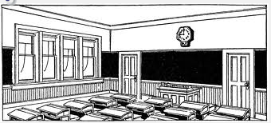

1) The Canteen

2) The Tuck-shop

3) Room 20

4) Room 18

5) Room 17

6) Room 7

**Possible murder weapons:**



1) A wooden metre ruler

2) A large metal stapler

3) A dusty trundle wheel

4) A sharp compass

5) A large maths textbook

6) An oversized calculator

# 

**Clue number 1:**

PDA NKKI PDA IQNZAN PKKG LHWYA EJ EO W JQIXAN.

Hint: Maybe some frequency analysis would help crack this Caesar Cipher?

**Clue number 2:**

Ht me ru ed er hr da ta po no ht ta ah sd rt pi se

Hint: maybe letters could be swapped around somehow?

**Clue number 3:**

tcejbolatematonsawnopaewredrumeht



**Clue number 4:**



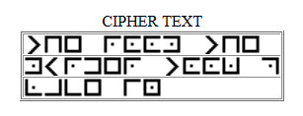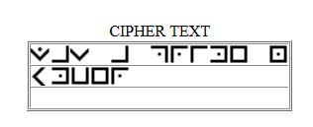

**Clue number 5:**

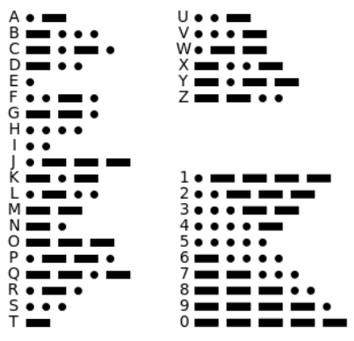

1 0000 0 010 0 00 000 01 1 0 1001 1 1000 111 111 101 11 00 000 000 00 10 110

**Clue number 6:**

TRTURKCIURYPODUHOHRTPESMMPLNECIOEDOLIABAEESRKSMMEOANNENOCILY

Hint: Could splitting this into 4 lines of equal length help?

**Clue number 7:**

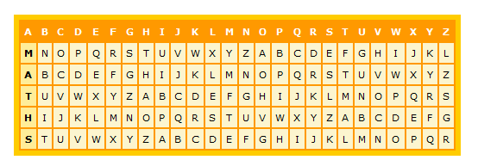

FHXTMDDXYWDWTZOQAKPFSTKVMEEKZ

Hint - Go along the M row and find F. What letter is above it on the top row? Now perhaps go to the second row.....

**Clue number 8:**

ʇɥǝ unɯqǝɹ oɟ sʇɹıdǝs ou ʇɥǝ ʇ sɥɹʇ ıs ɐu ǝʌǝu dɹıɯǝ unɯqǝɹ